**Inner Throne website – Solutions and fixes**

**Email Notification**

Location: Themes function.php

Functions –

* create_user_email_reminder
  + A logged in user can create reminder emails for themselves.
  + Only admins can make it for others, they do this by making the same request but adding a userid field
  + You can set half days – purposely used floatval
  + It must have a subject, message and a number for days
  + Admin checks to ensure people cant spam others
  + Array sent to user a new user meta then success message sent
* check_user_email_reminders
  + It checks the db for reminders in the usermeta
  + If found it checks to see if they fall before the current time
  + Then it sends the email (current commented out)

As mentioned in the comment above the check user function, wp_cron is limited and only runs if the site is in use. This is fine if it is constantly. But if no one is using it, no users will get notified .

The fix for it is to connect it to the systems cron.

**Isolate and fix blank page**

Location: Plugin – ryit-fellowship.php

Fix: A incomplete p tag was the cause, I also put a try catch in just in case

**Fix problems with stretch goal contents not showing on Safari**

Location: Plugin – user-profile.css

Fix: As seen in the screenshot below the , the specific element is under each stretch goals form, second element first child.

Effectively each acf field had max height 0 .

Quick fix is to just remove that line.

Full fix, is each acf-field has a class of “closed” when they open if they have it removed, that’s best.

#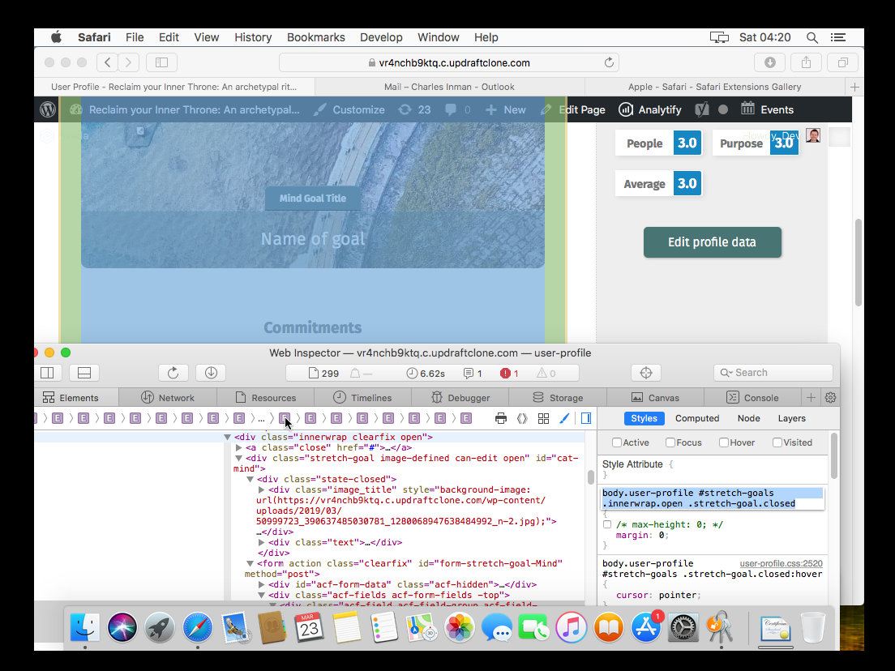

**Fix problem with Stretch Goal page jumping around on handheld browsers (confirmed behavior at least on Chrome)**

Location: as previous

Fix: Using chrome on android I couldn’t get this experience – but it is likely to do with it struggling to understand height which would be caused by the previous problem (unless there’s another)

**Prepare for delivering life assessment test non-logged in users**

Alternative approach: ideally you want to be gathering data on anyone who comes on your site, I’d suggest only having a simple sign up, which gets pushed to a more full sign up afterwards.

**Additional fixes**

**Ryit plugin system –**

I put in place a structure for the plugin there are still other requirements because the ryit-fellowship file is separate from the folder (which we don’t want ideally)

If the features are broken up into files and only loaded in when needed we can decrease loading times significantly

Js files need to have files created around core parts of the system – I put in guide controls which I think can be expanded on

**Edit and purchase history –**

I imagine on the live site the plugins that run this part of the site aren’t deactivated, but it is good practise to have code in place for the potential of them going wrong.

**Minor code changes –**

So, every time I came across something that I could see in the moment could be improved I did I put the below comment in to signify that I made a change there I do also explain what they are

// */*

Most of them are just small things like removing complexity that wasn’t needed

Most of the problems I came across working on this is not knowing where any of the code lives. Which is why separating them out helps points either of us in the right direction without crawling through thousands of lines.

It also makes it more modular, that way controls don’t need to be remade for each thing.

**The RYIT framework –**

You’ll notice I created a “steps” folder and 5 sub folders, we can load in all the files we need if theres a robust ajax system. It makes it look way smoother to the end users as well.

The subfolders I’d use for specific elements for that step otherwise theres a template that goes across everything.

Php is really good at loading in files insider other files. If each step gets broken down to the js css and core php file for that step, everything would load in, then later when theres content that changes its far easier to do using ajax, because your calling a file, not a huge functions file etc.